CANDIDATE RESUME

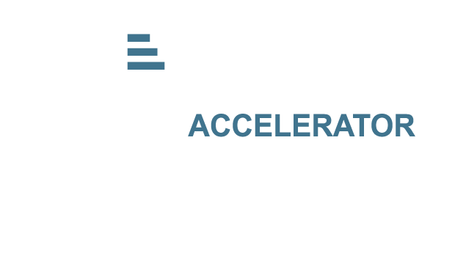

LUSANDA TSILANA

## Personal Details

About me

**Date of Birth:** March 31st 1999 **Residential Area:** Khayelitsha, Cape Town

**Languages:** English, isiXhosa, isiZulu

## Education

**Current**: CapaCiTi Software Development NQF Level 5 –

Learnership

**Current:** UNISA – Applied Mathematics and Computer Science

**2021**: UWC – Bachelor’s in Science: Biotechnology

**2017:** Harold Cressy High School –NSC

## Online Presence

**LinkedIn:** [www.linkedin.com/in/lusanda-tsilana-5b91a31a3](http://www.linkedin.com/in/lusanda-tsilana-5b91a31a3)

### GitHub:

<https://github.com/LusandaTsilana>

## Key Skills

* Sales
* Web Design
* Research
* Analytical Skills

I consider myself to be a hard worker. I am always driven to produce good quality work. Due to customer service/call center experience, I am accustomed to working with people and functioning in a fast paced environment. I am a life-long learner – always willing to try, learn new things and I am able to take feedback.

# Achievements & Key Projects

* Most dedicated individual in Software Development team at CapaCiTi
* Team Player, Great Patient Engagement, Time Management and Outstanding Quality Assurance as a Clinical Trial Recruiter at Subjectwell
* Bursary Award for Academic Achievements by Motsepe Foundation in 2020
* Distinction in Chemistry and Biotechnology in 2018 and 2019 at UWC
* Matric 2017 Distinction in Life Science

# Work Experience

**Software Development Learnership**

**Company: UVU Africa CapaCiTi**

January 2023 – Current

Worked in software development team to design and develop websites, applications, calculators and games based on client requirements. Had regular sprints to present work and implement feedback for finalized work.

* HTML
* CSS
* JavaScript
* Java
* Python

### Clinical Trial Recruiter

### Company: Subjectwell

June 2021- January 2023

* Provide information in clinical trials and conducting a basic medical screening
* Performing a screening to evaluate a patients eligibility for a trial
* Transferring pre-qualified patients to clinics for further screening

**Beauty Advisor**

December 2018 – January 2019

* Merchandising
* Replenishment
* Stock Count
* Make Overs
* Customer Service

# Tools

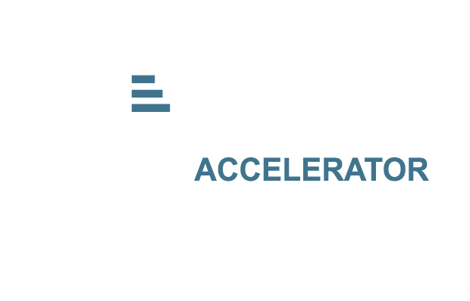

* + Visual Studio Code
  + GitHub

# Interests & Hobbies

* + Pharmaceutics
  + Mathematics
  + Music

# References

**Thandi Ndaba-Sher** Candidate Manager at CapaCiTi [thandi@capaciti.org.za](mailto:thandi@capaciti.org.za)

0848063374

**Nicole Tina Sampson**

Operational Team Lead at Subjectwell

073 247 0876

Nicole.Tina.Sampson@subjectwell.com

**Jayshree Periasawmy**

Cosemetics Manager at Foschini Store

081 534 5757

jayshreep@foschini.co.za